 | NORTH SOUTH UNIVERSITY
Project Report
of
Programming language I Lab (CSE115.8)

Submitted to

Anas Md. Ishfaqul Muktadir Osmani
Lab Instructor
North South University
Department of Electrical and Computer Engineering

Submitted by

Name | ID
Shadman Shawkat Bhuiyan | 2531920042
Abdur Rahman Yasin | 2531844042
Mahir Sadman | 2531065642
Musfiqur Rahman | 2321503043

Date of Submission: 23/12/2025
Stock Brokerage Management System

1. Introduction

- The Stock Brokerage Management System is a C-based console application designed to manage client records efficiently in a stock brokerage firm. The main purpose of this program is to provide an user-friendly system for storing, updating, searching, and deleting client information securely.

- This project addresses the problem of manual record keeping, which is time-consuming and error-prone. By using file handling and structured programming, the system ensures accuracy, data persistence, and easy retrieval of client information.

2. Background

- Traditionally, stock brokerage firms maintain client data using paper-based records or basic spreadsheets. These methods are inefficient and vulnerable to data loss. With the growing need for digital solutions, computerized management systems have become essential.

- This project is developed using the C programming language, which is widely used for learning core programming concepts. The system uses file handling, structures, and functions to simulate a real-world brokerage management environment.

3. Purpose and Benefits

- Purpose

- To design a easy-to-use stock brokerage client management system.

- To apply fundamental C programming concepts practically.

- To provide secure access through a login system.

- Benefits

- Reduces manual workload and human errors.

- Ensures secure access using username and password.

- Stores client data permanently using files.

- Allows quick search and update of client records.

- Easy to use and suitable for beginners.

4. System Features

The Stock Brokerage Management System offers the following features:

- User Login System

- Username and password-based authentication.

- Add Client

- Insert new client details into the system.

- View Clients

- Display all stored client records.

- Search Client

- Search by client name or client ID.

- Edit Client Information

- Modify existing client details.

- Delete Client

- Remove a client record permanently

- File Storage

- All data stored in clientdata.txt

5. User Stories

- User Story 1

“As a broker, I want to add new client information so that I can manage customer data efficiently.”

- Steps:

- Login to the system.

- Choose the “Add Client” option.

- Enter client details.

- Save the information.

- User Story 2

“As a broker, I want to search client records so that I can quickly access specific client information.”

- Steps:

- Login to the system.

- Select the “Search Client” option.

- Enter client name or ID.

- View search results.

6. Advantages

- Simple and easy-to-use menu-driven interface.

- Secure access using login credentials.

- Efficient file-based data storage.

- Low system resource usage.

7. Limitations

- Console-based interface only (no GUI).

- No encryption for stored passwords.

- Limited to local file storage.

- No internet or database connectivity.

- Cannot handle very large datasets efficiently.

8. Topics Covered

- The following C programming topics are used in this project:

- Structures

- File Handling (fopen, fclose)

- Functions

- Conditional Statements

- Loops

- String Handling

- Menu-driven Programming

- Input/Output Operations

9. Screenshots

- Creating profile and saving
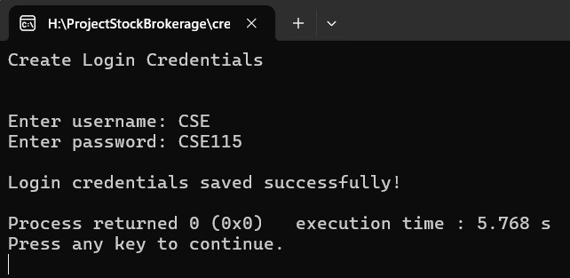

- User login from saved profile
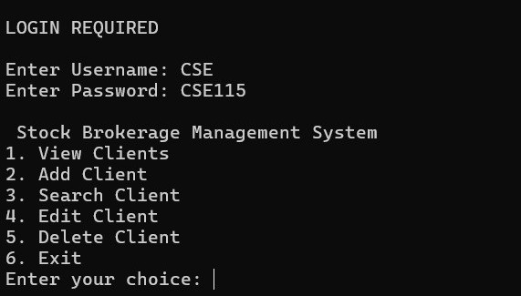
- Add client
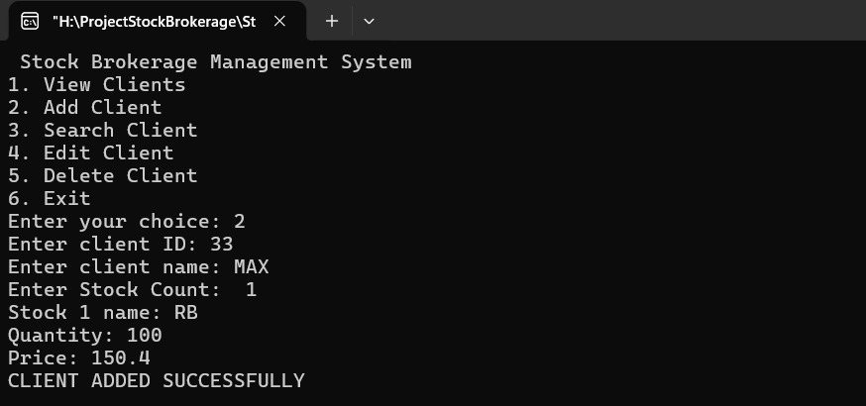
- View client
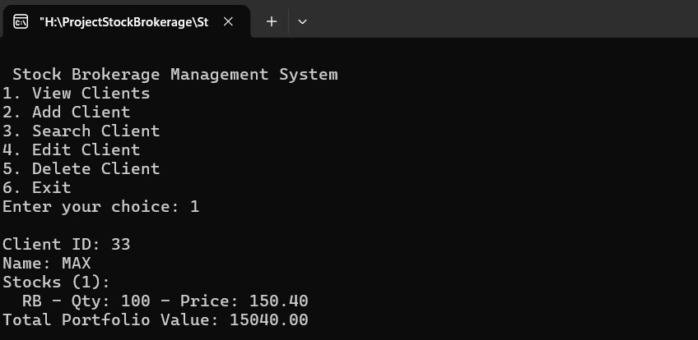
- Search client
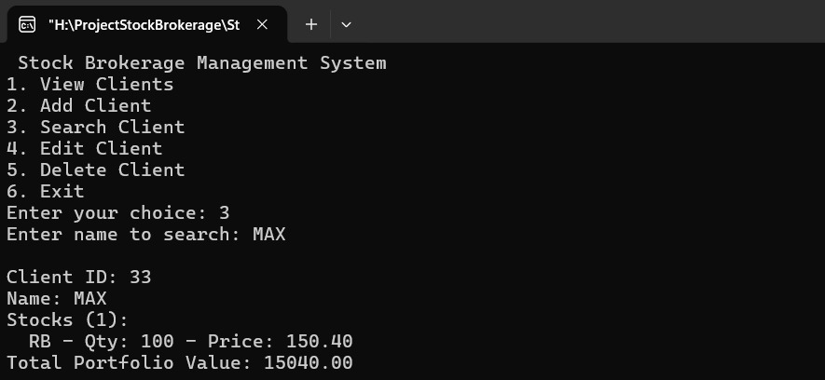
- Edit client
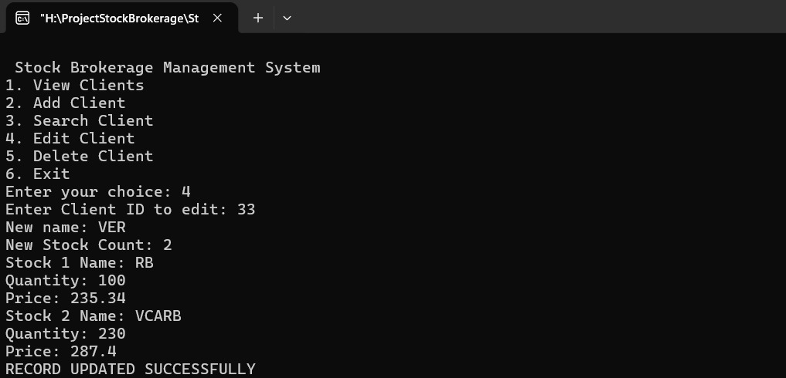
- Delete client
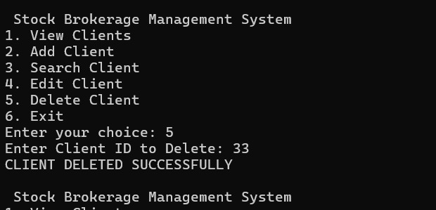
- Client data saved in ”clientdata.txt”
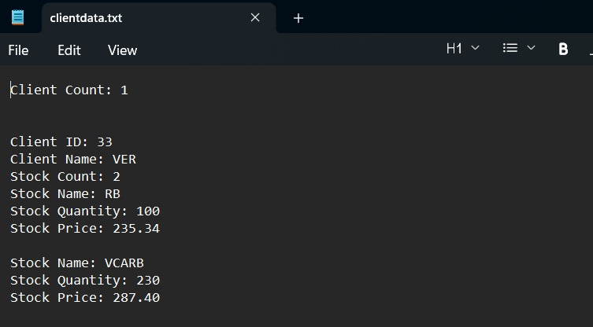

10. Future Work

- The system can be improved in the future by:

- Adding a graphical user interface (GUI).

- Implementing password encryption.

- Connecting to a database instead of text files.

- Adding transaction and portfolio management.

- Supporting multi-user access.

11. Team member contribution:

- Shadman Shawkat Bhuiyan

Project area: Testing and Documentation
Specific tasks: Client Editing Function, Client Deleting Function

- Abdur Rahman Yasin

Project area: Design and Development
Specific tasks: Main function, Login Function, File Loading, Adds a new client

- Mahir Sadman

Project area: File management
Specific tasks: Saves the file, Saving Client Data

- Musfiqur Rahman

Project area: Documentation
Specific tasks: Client Viewing Function, Client Searching Function

